Title (Arial, Bold, 14)
Authors: The author’s name(s) and affiliation(s) are in Arial, normal, 11, aligned to the left. An asterisk * is placed after the speaker’s last name. The affiliation of each author should be listed as place of employment or university.
Example:
Authors: Jill Dana^{1,} Jim Smith^{2,} 1. Rocks Geoscience, 2. Quartz College
Abstract
You will replace this text with your own text. The font for this template is Arial, the Section Headings are 10-point bold Arial and the text of the abstract is 10-point Arial.

Statement of the background

This section should state clearly the problem being addressed and its relevance to the topic of the technical session for which this abstract is intended.

Aims and Objectives

This section should expose the general aims and specific objectives that follow logically the statement of the background of the previous section.

Materials and methods

This section should provide a brief summary the field area / geological setting / material being investigated, why they are suitable to address the problem at hand and the proposed methods to achieve the aims and objectives.

Results and discussion

This section should address significant results in relation to the stated problem and discuss the applications and limitations of the proposed methods and interpretations.

Conclusions

Conclusions should shed light and provide possible avenues for future developments and applications on the problem being investigated.

This frame is not locked in place and will move with your text. You can place an equation or external file in this frame and add text before and/or after the object. The frame will automatically enlarge as you enter text, and can be formatted with or without a border. This frame has a single line border. To change the border of the frame, left click inside the frame, click Format on the menu bar, and then select Borders and Shading.

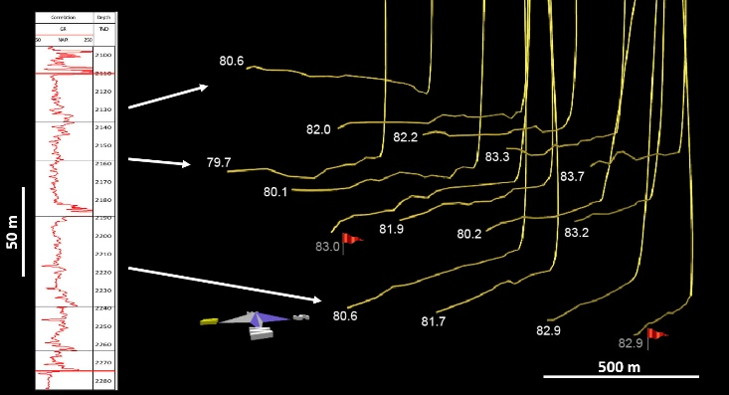
This is an example of an imported JPG file. Left click on Insert on the menu bar and then select Object (in the “Text” group). You can either embed an existing file (“create from file”), or create your object at that point. You can also insert a Picture instead of an object.
Figure 1: To create automatically-numbered captions like this one, select your object or picture, go to the “References” tab and click “Insert Caption.” Please use this format for your captions.

References

Gibson, D.W. and Barclay, J.E. 1989. Middle Absaroka Sequence - the Triassic stable craton. In: Western Canada Sedimentary Basin - a Case History. B.D. Ricketts (ed.). Canadian Society of Petroleum Geologists, Special Publication No. 30, p. 219–232.

Henderson, C.M. and Schoepfer, S. 2017. High-resolution biostratigraphic and XRF-geochemical correlation of the Montney Formation, NEBC. CSPG CSEG CWLS Joint Annual Convention, May 15–19, 2017, Calgary, AB.

Moslow, T.F. and Davies, G.R. 1997. Turbidite reservoir facies in the Lower Triassic Montney Formation, west-central Alberta. Bulletin of Canadian Petroleum Geology, v. 45, p. 507–536.

